

**MAHARASHTRA STATE BOARD OF TECHNICAL EDUCATION (MUMBAI)**

**INDUSTRIAL TRAINING REPORT**

On

**“R3 SYSTEMS INDIA PVT.LTD”**

In partial fulfillment for the Completion of course

**Industrial Training - 22057**

in the Programme

**Computer Technology**

****At

**K. K. WAGH POLYTECHNIC, NASHIK**

**Academic Year 2023-24**

NNN

**Submitted By:**

Name: Shraddha Punjaram Gaidhani

Seat No.____________

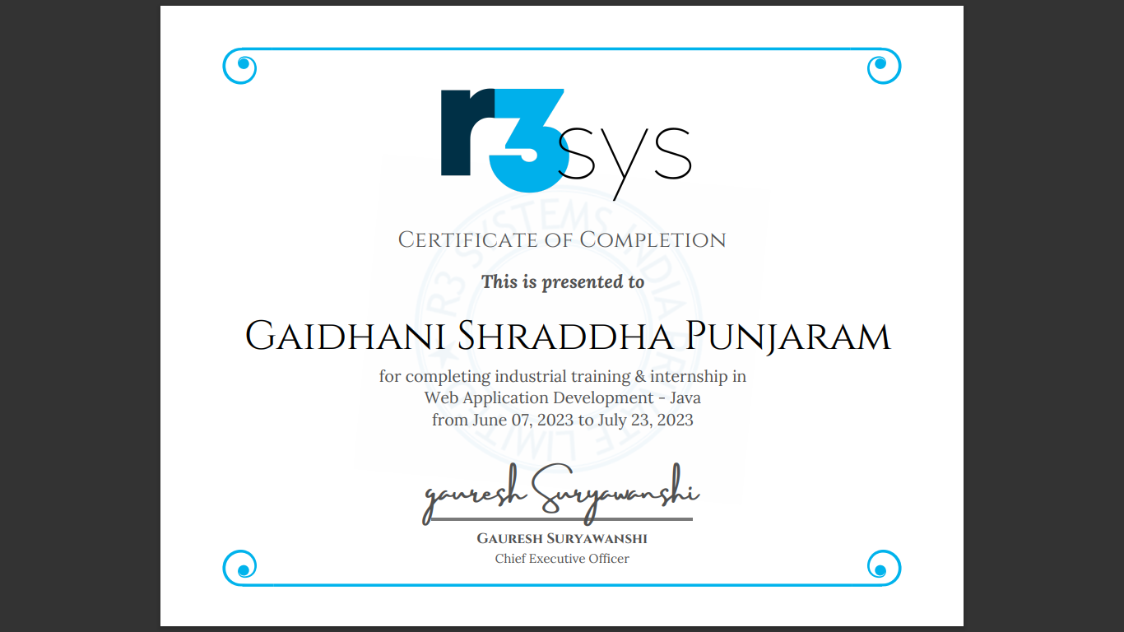

**ACKNOWLEDGEMENT**

It is indeed a great pleasure and proud privilege for me to present this in plant training report at **“R3 SYSTEMS INDIA PVT.LTD”**, one of the pioneered industries in software development & Consultancy. This training provides me with the first and the best opportunity to put my engineering knowledge to practical use.

I must be thankful to management of **“R3 SYSTEMS INDIA PVT.LTD”**, for giving me such opportunity.

I express my sincere gratitude to all Team Lead & Training Coordinators for not only guiding me through the training period but also sharing their immense knowledge and technical experience with me at every stage.

I also express my gratitude to the Mentor Mr. S. H. Sangale for great guidance and mentorship.

I am also thankful to all the staff members our mentor who directly and indirectly inspired and helped me for completion of this training period.

**INDEX**

|  |  |  |
| --- | --- | --- |
| **Chap No.** | **Title of Chapter** | **Page No.** |
| **1.** | **Introduction to Industry/Organization and its Organization structure** | **5-8** |
| **2.** | **Types of Software tools used with their specification** | **9-10** |
| **3.** | **Training course contents/outline/syllabus** | **11-12** |
| **4.** | **Summary of each Topic/Subtopic of course contents** | **13-14** |
| **5.** | **Assignment/Quizzes/Exam elaboration and Summary table** | **15-17** |
| **6.** | **Particulars of practical Experiences in industry** | **18-19** |
| **7** | **Short report/Description of the project** | **20-25** |
| **8** | **Special/Challenging experiences encountered during training** | **26-27** |
| **-** | **Conclusion/References** | **28** |

#### Chapter 1

**INTRODUCTION TO INDUSTRY & ORGANIZATION STRUCTURE**

We at R3 Systems are a group of IT experts, R3sys is a graceful and lean product development and IT service provider. We develop as well as co-develop mobile application, web portals and analytics solutions. In this advance world, R3sys is always there to help you to go through these IT challenges and get connect you to the world in most efficient manner. We are building our skill sets to find the defects in the current market an correct them with our unique solution of what a real satisfying business relationship should be like.

R3 Systems wanted to bridge the gap where most outsourcing companies fail with their customers, we have managed successfully to so that.

* Vision and Mission
* Vision

R3sys company's prime concern is "Customer Satisfaction," which they consider essential for all their team members to realize. The company values their team's learning perspective, dedication, and target-oriented approach, as it enables them to meet and exceed customer expectations. R3sys' ultimate goal is to serve with loyalty and provide quality services to their customers, fostering long-lasting relationships that will make them a memorable presence in the field for years to come.

* Mission

R3sys company's vision is to provide the best services within the deadlines set by their clients. They strive for growth achieved through exceptional client service, innovation, quality, and unwavering commitment.

* **COMPANY/ INDUSTRY PROFILE: -**
* **Name of the Company** :- R3 SYSTEMS INDIA PVT.LTD
* **Location/ address** /**Pin code** : - First Floor, Rohini Apartment, KBTCircle, GangapurRoad, NearSaraswatBank, ThatteNagar, Nashik,Maharashtra- 422005,India
* **Establishment** : - 2017
* **Email & Web Address** :- india.r3sys@gmail.com https://www.r3sys.com/
* **Name and Designation of Contact Person:-** Mr. Gauresh Suryawanshi (Chief Technical Officer)
* **Contact No:-** 8600033181
* **Type of Product:-** ( IT Software Development & Consultancies)
* **Type of Control :-** (Private )
* **Type of Company :-** (Small Scale )
* **Total Number of Employees in Company :-** 30
* **Total Turnover of Company :-** 20 Lakh
* **SERVICES PROVIDED BY R3 SYSTEMS:**
* Web Design & Development
* Mobile App Development
* Digital Marketing
* Project Consulting
* Corporate Training
* **Following Mentioned are the current employees working for the R3 System Software.**

|  |  |  |
| --- | --- | --- |
| Sr. No | Department | No. of Employees |
| 01 | Admin | 03 |
| 02 | Account Department | 01 |
| 03 | Core Development | 06 |
| 04 | Training Department | 02 |
| 05 | Testing & Implementation | 03 |
| 06 | Marketing & Sales | 02 |
| 07 | Cleaning & Safety | 01 |

* **GENERAL LAYOUT OF THE INDUSTRY/ORGNIZATION:**

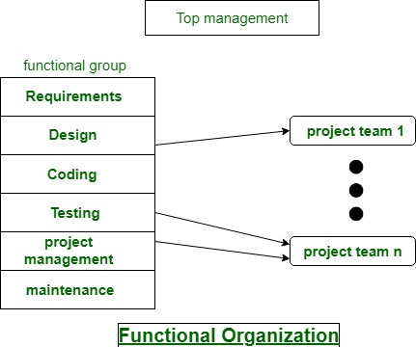

* **Technologies and Work**

R3SYS has worked with 100+ clients completing 100+ projects with 9000 hours of support.

The technologies used are:

* Java
* HTML/CSS
* Angular
* .NET
* Python
* Android
* PHP
* WordPress
* **CLIENTS**

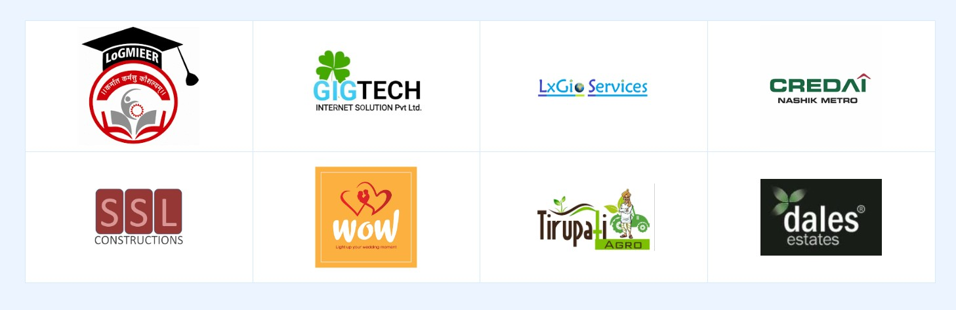

**History:**

R3 Systems is established in 2017, till now worked for 30+ clients and our team has more than 4-5 years of experience. We are building our skill sets to find the defects in the current market an correct them with our unique solution of what a real satisfying business relationship should be like. R3 Systems wanted to bridge the gap where most outsourcing companies fail with their customers, we have managed successfully to so that.

**Chapter 2**

**TYPES OF SOFTWARE TOOLS USED WITH SPECIFICATION**

**2.1.1. Laptops**

**Specification**

* Processor: up to Intel Core i5-2410M 2.3 GHz.
* Graphics: ...
* Memory: up to 8GB DDR3.
* Storage: up to 256GB SSD & 1 TB Hard Disk Drive.
* Optical Drive: a dual layer DVD reader/writer.
* Display: 15.6" (HD, maximum resolution of 1600 × 900)
* Web Camera: integrated.

**2.1.2 XAMPP**

The XAMPP application for Local hosting of Websites. XAMPP has the ability to **serve web pages on the World Wide Web**. A special tool is provided to password-protect the most important parts of the package. XAMPP also provides support for creating and manipulating databases in MariaDB and SQLite, among others.

**2.1.3 Eclipse**

Eclipse is a free, Java-based development platform known for its plugins that **allow developers to develop and test code written in other programming languages**. Eclipse is released under the terms of the Eclipse Public License.

**2.1.4 Wordpress**

WordPress is **a content management system (CMS) that allows you to host and build websites**. WordPress contains plugin architecture and a template system, so you can customize any website to fit your business, blog, portfolio, or online store.

**2.1.5 Approximate cost and specific use and their routine maintenance:**

**Laptop Cost:** 32,000 (Number of Laptop 10)

XAMPP, Android Studio, Eclipse, Wordpress and Mysql software are open Source.

**Chapter 3**

**TRAINING COURSE CONTENTS/OUTLINE/SYLLABUS**

* 1. **Course contents/outline/syllabus:**

1. **Introduction to Software**
   1. What is software?
   2. Types of software
2. **Web Application Development**
3. Introduction to Web Application Software.
4. Importance of Web based application in industry.
5. Different Languages to develop the Web Application Software.
6. **Introduction to Core JAVA**
7. Introduction to java
8. Decision making statements
9. Looping Statements
10. Classes and Objects
11. Methods
12. different OOP concepts
13. Collection Framework
14. **Introduction to advance JAVA**

1.Introduction to Advance java

2.Introduction to Servlets

3. Introduction to JDBC (java database connectivity)

4.Application

1. **Servlets and JSP concepts**

1.Handeling the Servlets

2.Embedding java in html using JSP

1. **Web Based Languages (HTML, CSS)**

1. Introduction of HTML

2.Introduction to CSS

1. **Application**

1.Application

2.Implementation

**Chapter 4**

**SUMMARY OF EACH TOPIC/SUBTOPIC OF COURSE CONTENT**

* 1. **Summary of Contents:**

**1. Introduction to software**

Software is **a set of instructions, data or programs used to operate computers and execute specific tasks**. It is the opposite of hardware, which describes the physical aspects of a computer. Software is a generic term used to refer to applications, scripts and programs that run on a device. Softwares are categorized in multiple types, i.e. web application, mobile application, Real time, product based, etc.

1. **Web Application Development**

A Web application (Web app) is **an application program that is stored on a remote server and delivered over the Internet through a browser interface**. Web services are Web apps by definition and many, although not all, websites contain Web apps. According to Web.

Web applications include **online forms, shopping carts, word processors, spreadsheets, video and photo editing, file conversion, file scanning, and email programs such as Gmail, Yahoo and AOL**. Popular applications include Google Apps and Microsoft 365.Developed by using either java or .net.

1. **Introduction to Core JAVA**

Java is **a widely used object-oriented programming language and software platform** that runs on billions of devices, including notebook computers, mobile devices, gaming consoles, medical devices and many others. The rules and syntax of Java are based on the C and C++ languages.

Java is **a widely used object-oriented programming language and software platform** that runs on billions of devices, including notebook computers, mobile devices, gaming consoles, medical devices and many others. The rules and syntax of Java are based on the C and C++ languages.

1. **Introduction to advance JAVA**

Advanced Java is **everything that goes beyond Core Java** – most importantly the APIs defined in Java Enterprise Edition, includes Servlet programming, Web Services, the Persistence API, etc. It is a Web & Enterprise application development platform which basically follows client & server architecture.

1. **Servlets and JSP concepts**

Servlet is **a class that handles requests, processes them and reply back with a response**. For example, we can use a Servlet to collect input from a user through an HTML form, query records from a database, and create web pages dynamically.

JSP is used **to create dynamic web content**. In this JSP tags are used to insert JAVA code into HTML pages. It is an advanced version of Servlet Technology. It is a Web based technology helps us to create dynamic and platform independent web pages.

1. **Web Based Languages (HTML, CSS)**

HTML (Hyper Text Markup Language) is **the code that is used to structure a web page and its content**. For example, content could be structured within a set of paragraphs, a list of bulleted points, or using images and data tables.

Cascading Style Sheets (CSS) is **a stylesheet language used to describe the presentation of a document written in HTML or XML** (including XML dialects such as SVG, MathML or XHTML). CSS describes how elements should be rendered on screen, on paper, in speech, or on other media.

1. **Application**

By using Java,Html,Css we can develop a variety of applications such as **enterprise applications, network applications, desktop applications, web applications, games, android app**, and many more. In this section, we will focus on what is Java used for, the applications of Java, and why we use Java.

**Chapter 5**

**ASSIGNMENTS/QUIZZES/EXAM ELABORATION AND SUMMARY TABLE**

**5.1 Assignment:**

**1.Banking Application:**

This is dynamic web application which handles database , servlet and JSP pages. Frontend is developed with Html, css and javascript. In backend there is MySQL database. In this application you can perform different operations like adding/registering new user, deleting the user, updating the user’s information, etc. This bank application provides you faculties to adding new account in bank, depositing the money, withdrawing the money, deleting the accounts and view the accounts.

**Features:**

1. Sign-in/sign-up
2. Resetting the password
3. Creating new account
4. Depositing the money
5. Withdrawing the money
6. Deleting the accounts
7. View the accounts
8. Slideshow photo gallery
9. Information of banking terms with multimedia
10. Logging off

**Output:**

**SS:- 1 Home Page**

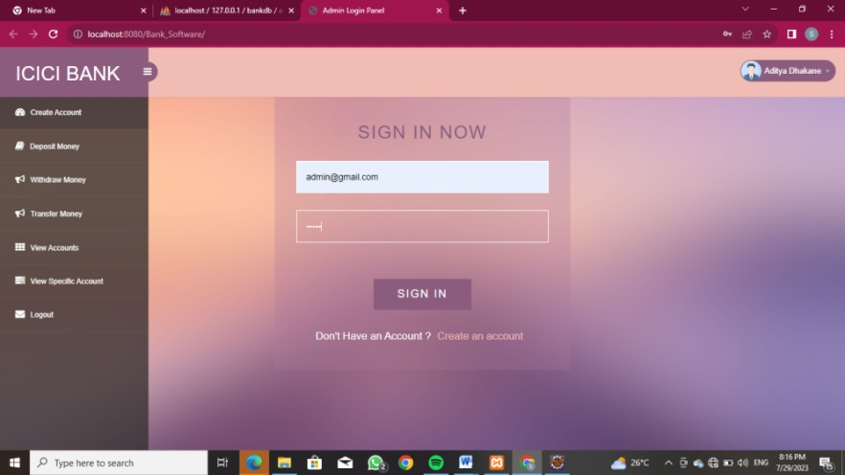

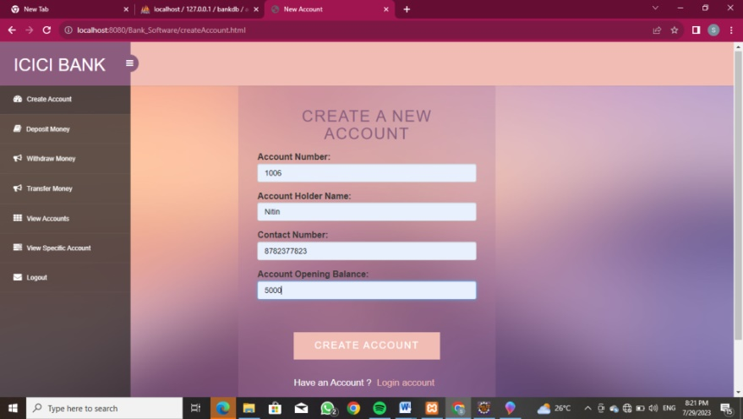**SS:- 2 Create an Account Section**

**SS:- 3 Deposit Money Section**

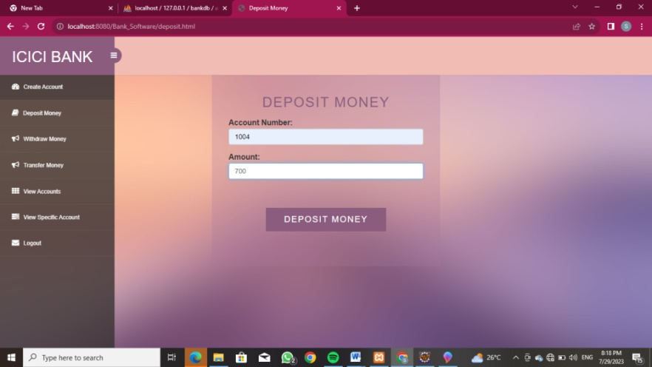

**SS:- 4 Withdraw Money Section**

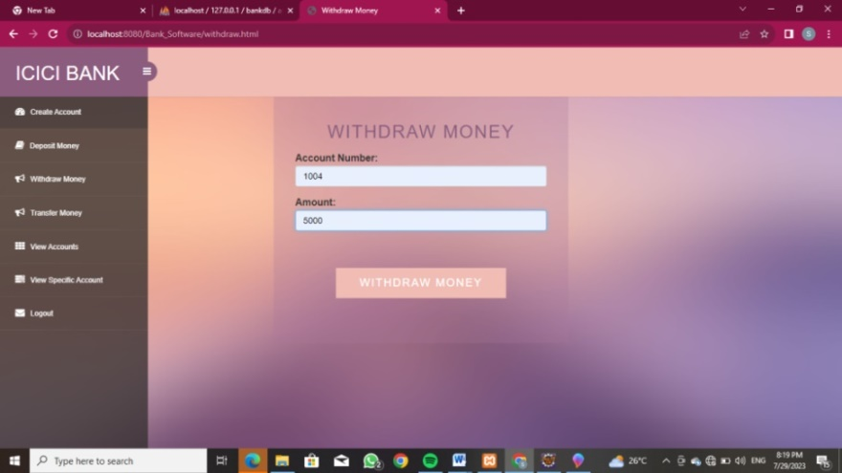

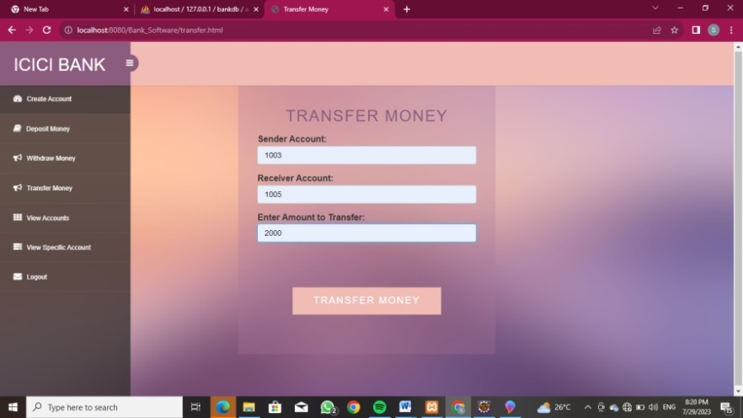**SS:- 5 Transfer Money Section**

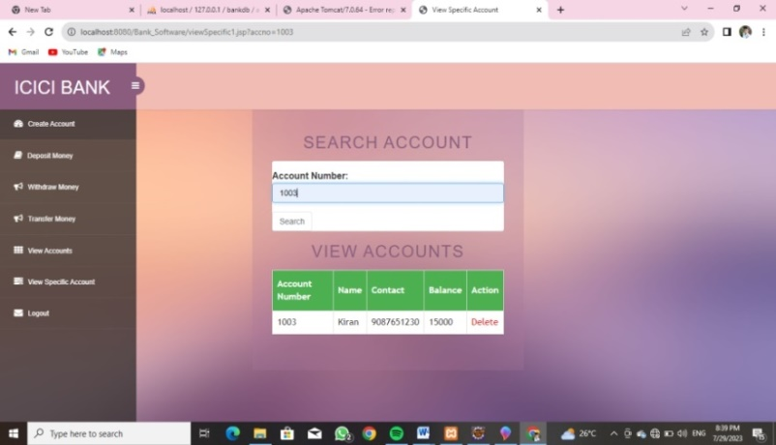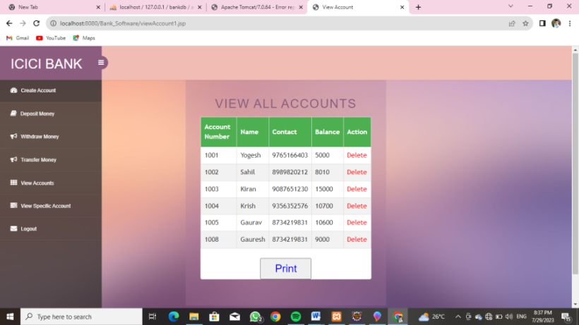**SS:- 6 View Accounts Section SS:-7 View Specific Accounts Section**

**Chapter 6**

**PARTICULARS OF PRACTICAL EXPERIENCES IN INDUSTRY**

**6.1.1 Projects**

Assignments were given to us as we progressively learnt new concepts, these assignments were build off of each other and required knowledge of previous topics to complete new ones.

Thus collection of these assignments and taught topics made up to a complete Web Application Devlopment report and dashboard.

* **Project Developed-**

1. Login template

2. Admission Registration template

3. Manipulation of data in table

4. Database handling

5. Banking application

6. Student Record application

7. Electric Vehicles charging station service application

**6.1.2 Experiences in Industry**

During our web application development project, we gained invaluable practical experiences in various facets of the industry. Through our projects, we honed our skills in Java, HTML, and CSS, enabling us to create robust and user-friendly web applications.

Firstly, we designed a sleek and efficient Login template, ensuring secure access and authentication for users. Next, the Admission Registration template provided a seamless and intuitive user interface for students seeking enrollment, streamlining the admission process.

Data manipulation in tables taught us essential techniques for handling and presenting information effectively. We delved into Database handling, mastering concepts like data modeling, querying, and optimization, essential for storing and retrieving data efficiently.

Our Banking application allowed us to understand the intricacies of financial transactions and security measures necessary to safeguard sensitive information. Meanwhile, the Student Record application demonstrated our proficiency in managing educational data, facilitating smooth academic processes.

One of our most innovative projects was the Electric Vehicles charging station service application. We embraced the emerging field of electric mobility, creating a platform that offered convenient access to charging stations, promoting sustainable transportation.

Throughout these projects, we learned the importance of collaboration, communication, and adhering to industry best practices. We faced real-world challenges and found creative solutions, demonstrating our adaptability and problem-solving abilities. This practical experience in the industry has equipped us with the necessary skills to excel as web developers and contribute to the digital landscape.

**Chapter 7**

**SHORT REPORT/DESCRIPTION OF THE PROJECT**

**Electric Vehicle Charging Service Application:**

EV charging service application is dynamic web application which provides EV charging related services to the user. As we know the popularity of Electric Vehicles are increasing day by day, peoples are buying Electric vehicles more and more. To make this service more easier this application will definitely helps.

**Languages used:**

1. Java (Servlet and JSP for jdbc connection)
2. Frontend – HTML , CSS and JavaScript
3. Backend – MySQL

**Features:**

1. Three different modules ( Admin, CNG pump and users)
2. Each containing Registration/Login/resetting password
3. Different facilities are provided to different user
   1. Admin- view and deleting EV charging stations
   2. EV Charging Station - update the charging, view the charging stations
   3. User- view the EV charging stations
4. Handling and managing Projects
5. Managing the data and information given by different user

**Output:-**

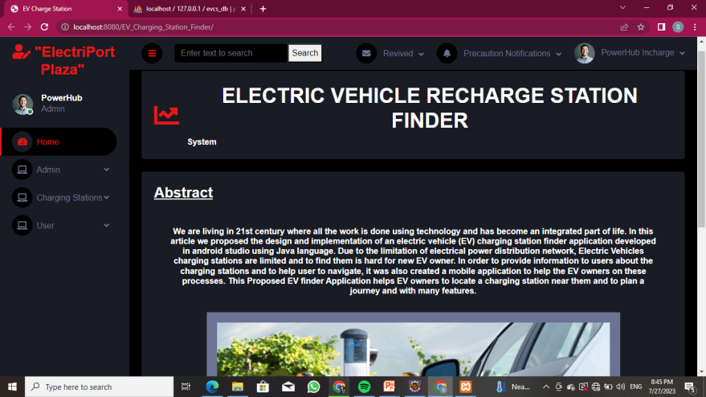**SS:-1 Home Page**

**SS:- 2 Admin Module**

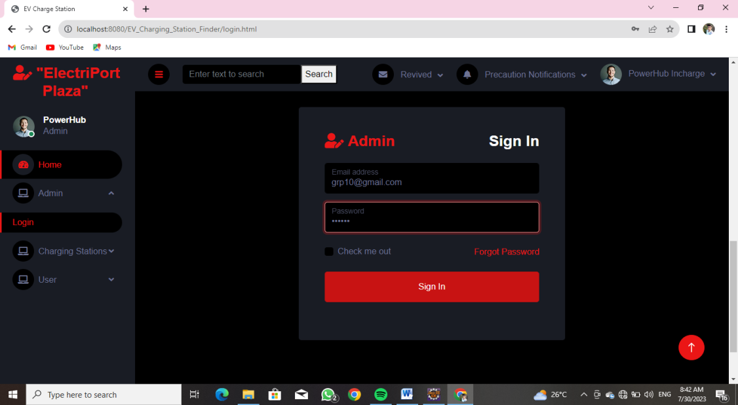

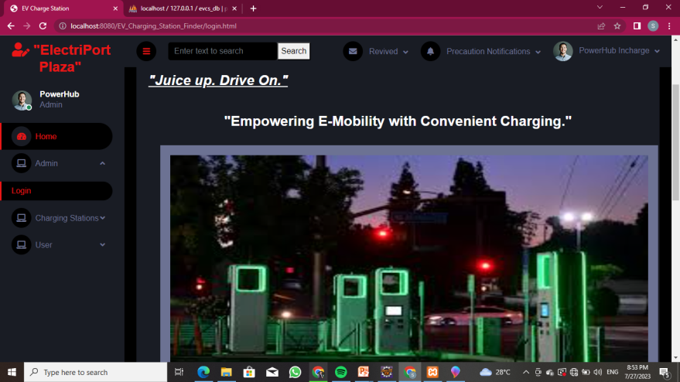

**SS:- 3 After Admin Login :- Shows Admin Menu**

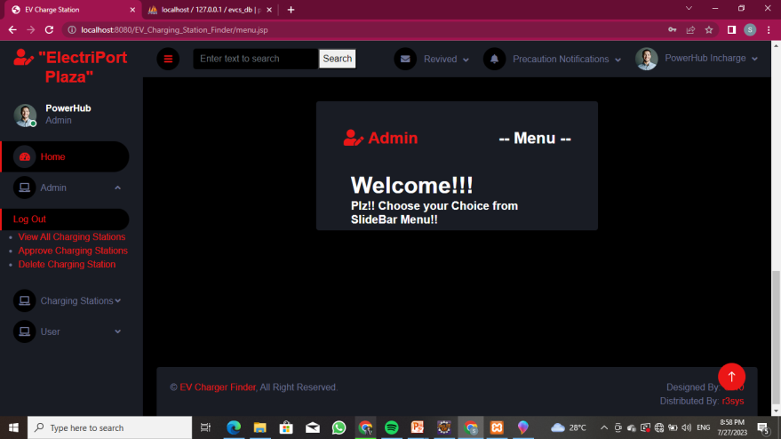

**SS:- 4 Admin Module SubMenu   
4.1) View All Charging Station**

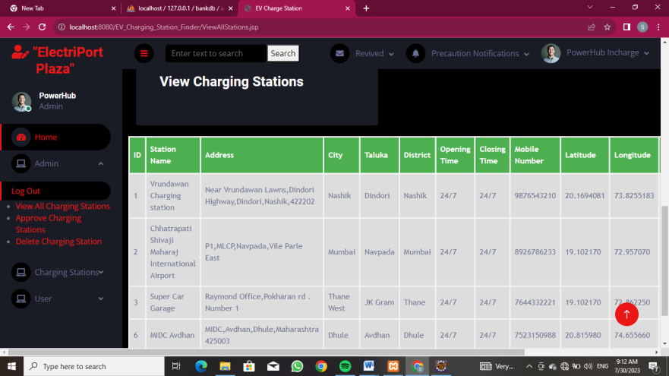

**4.2) Approve Charging Station**

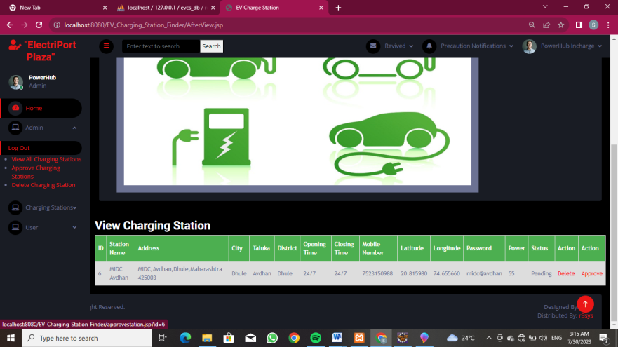

**4.3) Delete Charging Station**

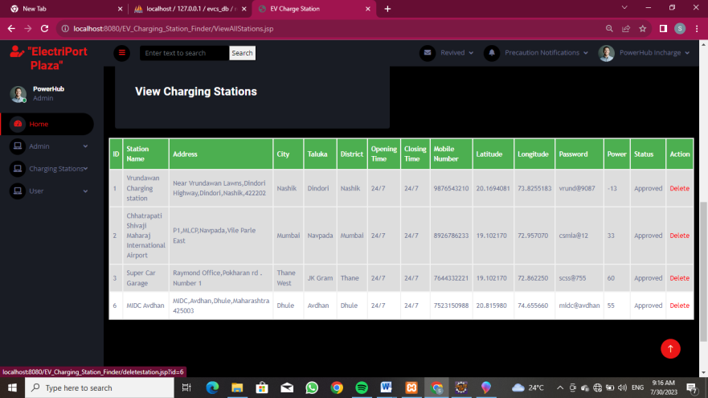

**SS:- 5 Charging Station Module**

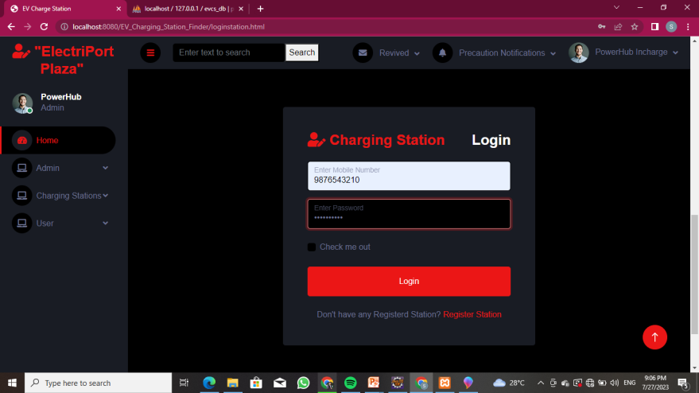

**SS:- 6 After Charging Station Login:- Shows Charging Station Menu**

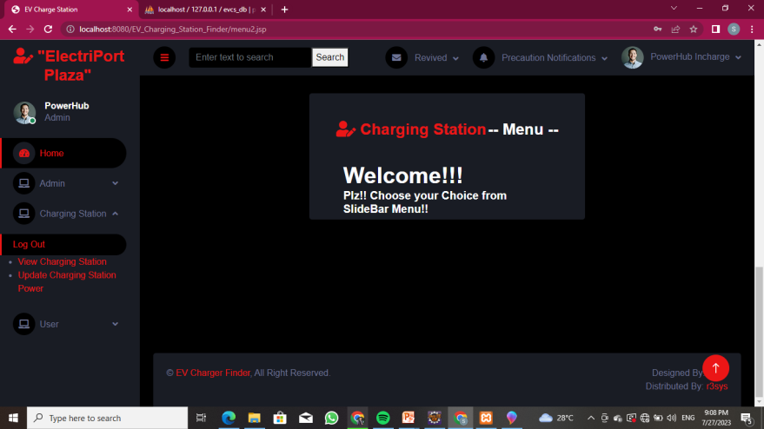

**SS:- 7 Charging Station Module SubMenu  
7.1) View Charging Station**

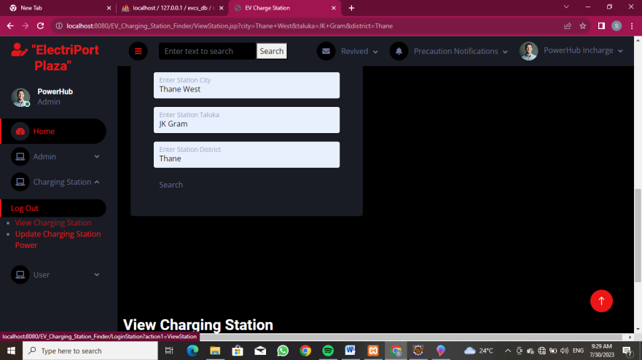

**7.2) Update Charging Station Power**

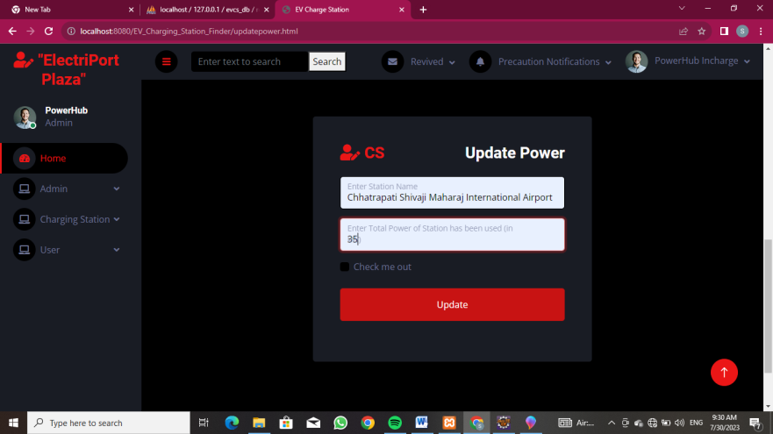

**SS:- 8 User Module**

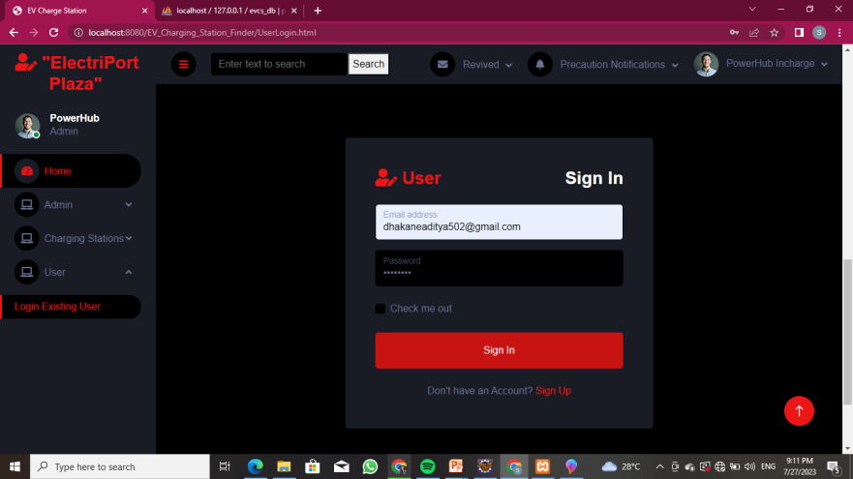

**SS:- 9 After User Login:- Shows User`s Menu**

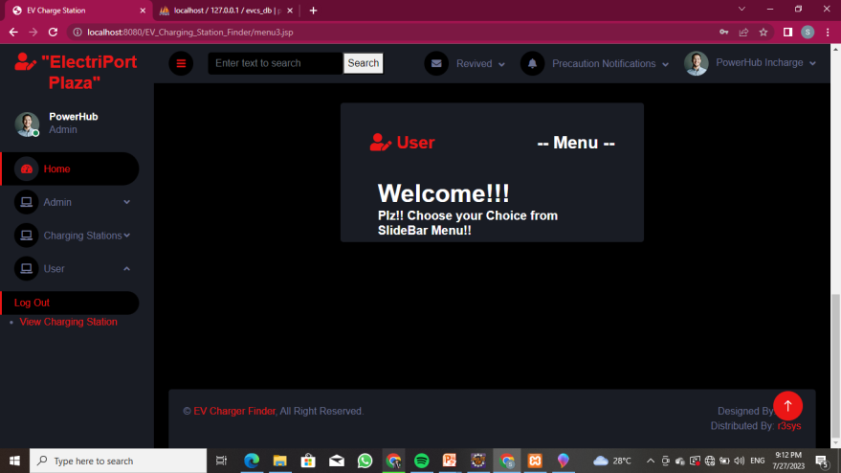

**SS:- 10 User Module SubMenu  
10.1) View Charging Station**

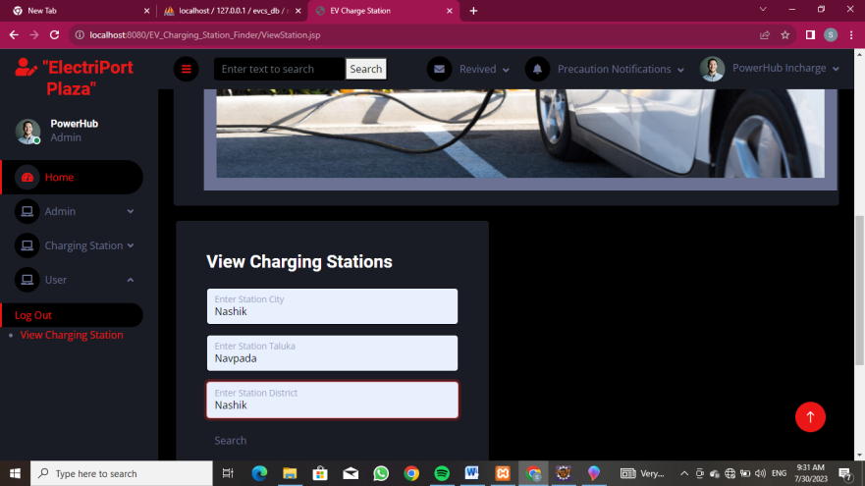

**Chapter 8**

**SPECIAL/CHALLENGING EXPERIENCES ENCOUNTERED DURING TRAINING**

**8.1.1 Experienced challenging and special experiences:**

During our training in web-based project development, we encountered a range of challenging and special experiences that enriched our learning journey:

* **Complex Feature Implementation:**

We faced challenging scenarios while implementing complex features, such as real-time chat functionality and payment gateways. These experiences tested our problem-solving skills and deepened our understanding of web technologies.

* **User Experience Optimization:**

Enhancing the user experience required thoughtful design decisions and continuous feedback gathering. We learned to analyze user behavior, conduct usability testing, and make iterative improvements to the interface for maximum user satisfaction.

* **Cross-Browser Compatibility:**

Making the application compatible with different web browsers was a real-world challenge. We addressed browser-specific quirks and inconsistencies to ensure a consistent user experience.

* **Security Considerations:**

Addressing security concerns was a top priority. We focused on safeguarding sensitive user data and implemented measures like input validation, secure authentication, and protection against common web vulnerabilities.

* **Performance Optimization:**

Optimizing the application's performance was an ongoing task. We delved into techniques like code optimization, image compression, and caching to reduce loading times.

* **Working under Deadlines:**

Managing project timelines and adhering to strict deadlines taught us valuable time management skills.

Some other challenging and special experiences encountered during Training are as follows-

* Time-consuming training creation.
* Use of advanced training tools.
* Manual delivery of quizzes.
* Outlining Training Content.
* Keeping the learners engaged.
* Boring course templates.
* Information overload.
* The need for peer collaboration
* Learning new things in new day
* Working with group of co-members

These challenging and special experiences during our web-based project training not only enhanced our technical skills but also nurtured our professional growth. We emerged as adaptive and resourceful developers, ready to embrace the exciting challenges that lie ahead in the industry.These experiences challenged us to think critically, work collaboratively, and apply our technical skills effectively to overcome obstacles. They provided invaluable lessons that will undoubtedly shape our future endeavors in web development.

**Conclusion:-**

The six-week industrial training program at R3SYS India Private Limited was a valuable and transformative experience. I gained comprehensive knowledge and hands- on expertise in Web Development and its various components. It was good & memorable experience of the 6 weeks in the company. During the training I got technical & practical knowledge in fact it was opportunity to me to observe, how the various departments co-ordinate in between them & how they were trying to plan, organize, control & manage the work properly to achieve the organizational goals.

The guidance and mentorship provided by the experienced professionals at R3SYS India Private Limited was instrumental in shaping my proficiency in Web Development. The continuous support and constructive feedback helped me improve and refine my technical abilities. Additionally, collaborating with a dynamic team of like-minded individuals fostered an environment of learning and innovation.

I am grateful to R3SYS India Private Limited for providing me with this incredible opportunity to grow both personally and professionally. In conclusion, the industrial training program at R3SYS India Private Limited has been a rewarding journey that has not only enhanced my technical acumen but also ignited a passion for data-driven decision-making. I am confident that the skills I have acquired here will be instrumental in shaping a successful and fulfilling career ahead.

I am very thankful to my college and industry for making me familiar with industrial environment.

**References / Bibliography:**

R3 SYSTEMS INDIA PVT.LTD

* + List of web references taken:
    - https://www.w3school.com/
    - https://www.bootstrap.com/
    - https://www.r3sys.com/
    - https://chargefinder.com/en
    - https://nexonev.tatamotors.com/charging-locator/

**Physical location:**

First Floor,Rohini Apartment, KBT Circle, GangapurRoad, Near Saraswat Bank, ThatteNagar,Nashik,Maharashtra- 422005,India